PRINCESS POCOTOPAUG CORPORATION ANNUAL MEETING
CLUBHOUSE on Seminole Trail & ZOOM @
https://us02web.zoom.us/j/88177017409?pwd=U2lqSERNM3NodlJ4TE5kdkZTWmJSZz09
www.princesspocotopaug.com
To all Members:
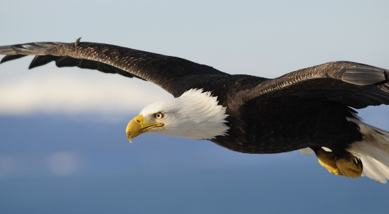
Hello neighbors. Another year, another us. All meetings, unless informed otherwise, will be held at the Clubhouse, including our annual meeting. All members are invited and encouraged to attend. The annual meeting’s ZOOM link and monthly meetings are the same, and can always be found on our website, but also listed on top of this header. We kindly ask you to attend meetings to offer suggestions, hear about upcoming events, and to simply stay up to date with the association’s efforts. Most importantly, we have many tasks and responsibilities that could always use more assistance/ volunteers.
The highlights of our 2025-2026 year include:
- Clubhouse Cleaning and Painting.
- Various landscape cleanups and plantings.
- Kayak and Canoe organization.
- Beach security upgrades.

Highlights planned for 2026-2027 year include: (if passed)
- Ongoing Clubhouse repairs and upgrades.
- North Launch repair.

Our 2026 annual meeting will occur at our Clubhouse located at 9 Seminole Trail on Saturday, May 23, 2026 at 9am. Look for postings at the beaches, clubhouse and at the Town Hall.

Please always protect our neighborhood by staying alert and reporting activities like beach trespassing, wrongful/ unsafe boat launching, animal control issues, and parking. We urge you to always stay safe by reporting any suspicious activities and/or people to the town’s local police department at 860.267.9544. Also, friendly reminder to always lock your cars and homes.
Animal/ pet responsibility is always an ongoing focus, and we kindly remind everyone, dogs should always be leashed, and please respect your neighbors by properly disposing of waste, and controlling noise levels at all times of the day and/or night. Shall anything be witnessed that jeopardizes safety in any capacity, or violates association and/or town municipal prohibitions, please immediately address your concerns to the local police at 860.267.9544, animal control at 860.873.5044 and/or animalcontrol@easthaddam.org. Feel free to include president@princesspocotopaug.com on correspondences, however all actions MUST be directed to the town.
Beaches will remain locked at all times. Please always shut the gate behind you. Beach passes are not necessary, but all members will need the beach gate code. Current code is C0721. On July 1, the beach gates AND the South Beach Boat Launch lock will change to C1953. (Fun fact – 1953 is when the PPC was created)

I would like to thank this year’s team: Officers, Board of Directors, Alternate Directors, Committee Chairs, Dock Master, and our Social Committee for their efforts. We have such a hard-working Board who are always striving to preserve our properties. This year, we are in need of new/ more board of directors, and are currently taking requests to join, and nominations, immediately.
The agenda for the annual meeting on May 23 is enclosed.
Ryan Donohue,
President, Princess Pocotopaug Corporation EFFECTIVE JULY 1 – NEW BEACH CODES ARE C1953

